Title: | Instrument Cluster  SW Component

History
Issue status  (Index) | Maturity/Date  (draft/invalid/valid)  (dd-mmm-yyyy) | Author  Department | Check/Release  Department | Description
0.1 | Draft  25-Aug-15 | Edgar Mosqueda |  | Creation of the document

Table of Contents
1 Purpose 4
2 Definitions and abbreviations 4
3 Realization constraints and targets 5
4 SW Component internal breakdown 6
4.1 Component diagram 7
4.2 Use case diagram 8
The following diagram is the use case diagram in this system behavior is defined and how the user interacts with in the situation raised by the requirements. 8
4.3 State diagram 9
4.4 Sequence diagram 10
4.4.1 Function <Type> <function name> (type par 1, .., type par n) 11
4.4.2 Function <Type> <function name> (type par 1, .., type par n) 11
4.5 Macros 12
4.6 SW module global variables 12
4.7 Design solutions for general features 13
4.8 SW Component integration 13
4.8.1 Integration context / constraints 13
4.8.2 Include files 13
4.8.3 Initialization 13
4.8.4 Interrupts 13
4.8.5 Real time scheduler task 13
4.8.6 Other entry points 13

Purpose
This document has been created for to explain the behavior, feature, parts and components of the application. The document is divided in sections for better description; the sections are definitions, realization and constrain, internal components, variables, macros and more. The application will use a standard that is LIN protocol. The LIN protocol (Local Interconnect Network) is a concept for low cost automotive networks. The standardization will reduce the manifold of existing low-end multiplex solutions and will cut the cost of development, production, service, and logistics in vehicle electronics. The LIN is a serial communications protocol which efficiently supports the control of mechatronics nodes in distributed automotive applications.
The main properties of the LIN bus are:

- Single master with multiple slaves concept based on common UART/SCI interface hardware, an equivalent in software or as pure state machine.
- Speed up to 20 kbit/s.
- Signal based application interaction
- Predictable behavior
- Configurability

Definitions and abbreviations

Definitions and Abbreviations

References
N° | Document name | Reference
1 | PFinal-ID_Cluster Requirements | ..\..\PFinal-ID_Cluster Requirements (1).doc

Realization constraints and targets

The slave shall use LIN protocol 2.0, with 19.2kbps baud rate. The system contained 4 slaves and a master, for this implementation the slave that has to be model is slave1. The master node will send message to all slave and to specific slaves.
At first the slave1 state when is initialization shall be disable. The master node has to wake up the slave1.
There are 4 types of massages for slave1. All the messages shall include an ID. The signal endianness shall be little endian.
The message MASTER_CMD_ALL is send it by the master node to all the slave include slave1. The ID for this messages shall be 0xCF.
Messages MASTER_CMD_ALL should send the fallow commands to all the slaves: cmd_NONE(Will do nothing), Cmd_LED_on(Will turn on the led), cmd_LED_off(will turn off the led), cmd_LED_toggling(will toggling the led), cmd_disable_slv(will disable the slave and sets state) and cmd_enable_slv(will enable the slave and sets state).
There’s and specific messages for slave1: MASTER_CMD_SLV1 and is send it by the master node. The ID for this messages shall be 0x50.
Messages MASTER_CMD_SLV1 should send the fallow commands to slave1: cmd_NONE(Will do nothing), Cmd_LED_on(Will turn on the led), cmd_LED_off(will turn off the led), cmd_LED_toggling(will toggling the led), cmd_disable_slv(will disable the slave and sets state) and cmd_enable_slv(will enable the slave and sets state).

SW Component internal breakdown
For easy understanding the system, it has created from diagrams that it show the structure and behavior that’s why is dividing in layer, use case, state, sequence and component diagrams, those diagrams will explain the next way.
All system is implemented in scheduler rate monotonic type which provides time on tasks where invocation of functions is done by using the synchronization and timing features provided by the scheduler.
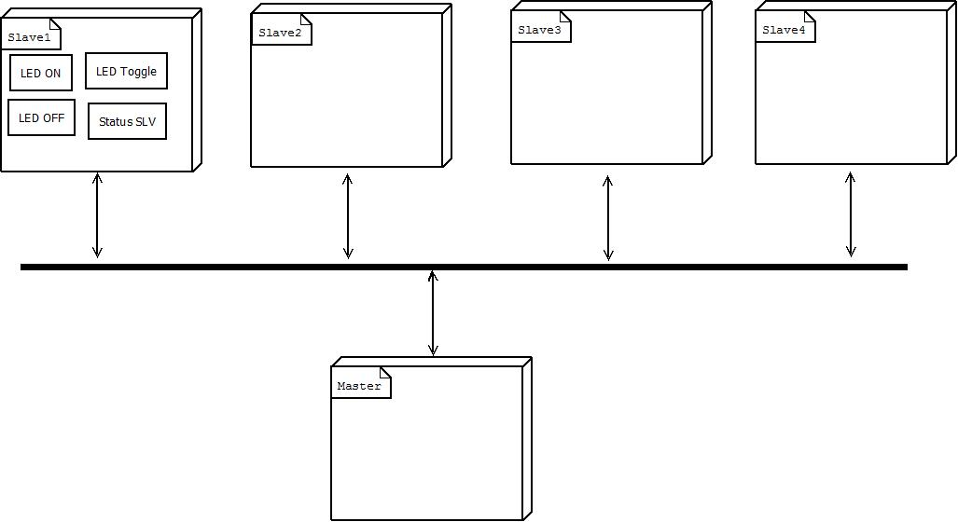

Component diagram
The SW is structured with layer programing for its portability so easy to other embedded systems, that’s why it has programed in this way. In the following picture is showing the layers diagram and its components.

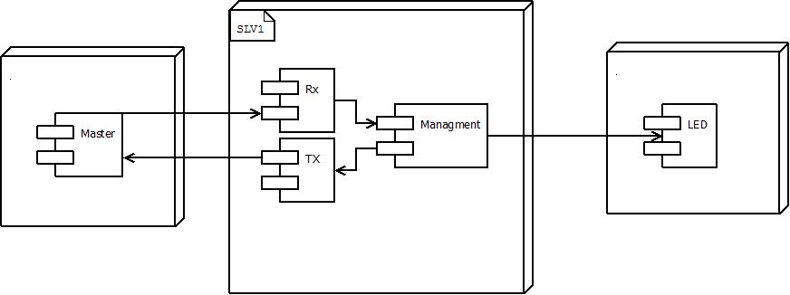

Master sends message and it’s received by component Rx and then passive to the slave management.
Component Rx the only feature is receive a message send it by the master.
Component Tx the only feature is sending a message to master.
Management analyze the frame if the ID corresponded to slave1 then will do the respective action.
If the ID doesn’t corresponded to salve1 ignore the signal.
LED component is an indicator and is controlled by the slave1.

Use case diagram

The following diagram is the use case diagram in this system behavior is defined and how the user interacts with in the situation raised by the requirements.
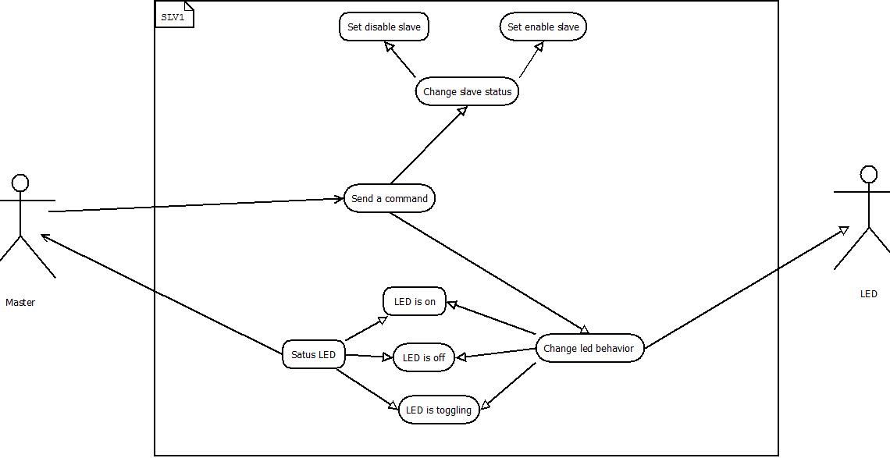

The master sends a command for change slave status or change led behavior and also, the master can requests the led status.
Led is on will turn on a led that’s depending the signal.
Led is off will turn off a led that’s depending the signal.
Led is toggling will toggilng a led that’s depending the signal.
The change slave status can to take two ways, either set disable slave or set enable salve.

State diagram
In this diagram has described the system, its features, the dynamic behavior and its process.

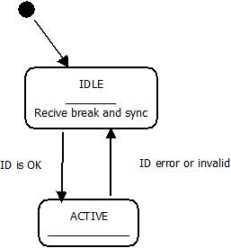

The slave can take two states: IDLE and ACTIVE.
IDLE will wait until receive break and the sync. Then will active the slave to send it to another machine state.
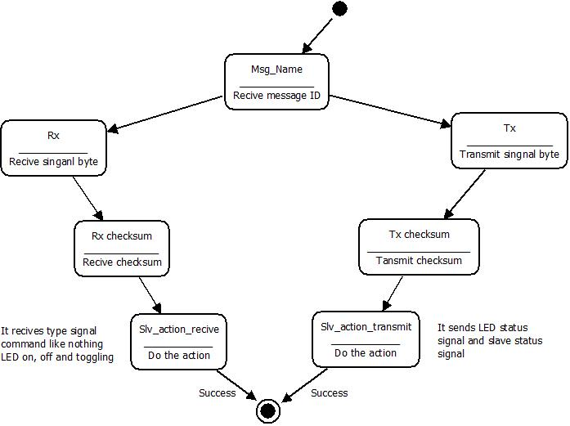

Msg_Name: Receive will check which ID is and see if corresponds to ID for slave1

Sequence diagram
In this diagram has shown the interaction between the objects the sequential way and its behavior.

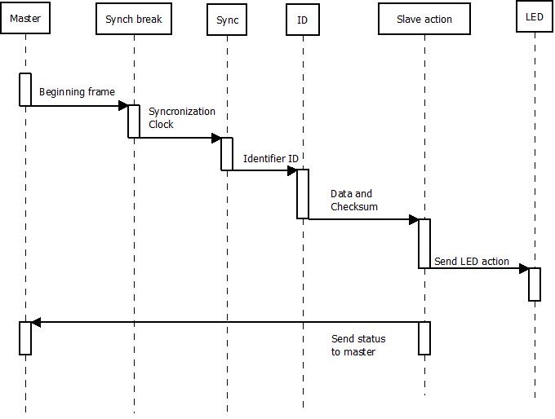

The master sends a frame for begin synchronization this frame are 13bits, after the master its synchronize clock with slave clock, the slave identifier ID contains the content and length of message, then DATA field consists of BYTE fields after CHECKSUM field contains the inverted modulo-256 sum over all data bytes calculated by “add with carry”, and once done this the slave send LED action or send status to master.

Function Description and Dynamic Behavior
Provide detailed static and dynamic description of all functions of the SW Component.
Functions which are defined in other SW Components shall only be referenced in the external interface description!
The signature description shall be done inside the function header in the source code.
For each function, the following section should be copied

Function <Type> <function name> (type par 1, .., type par n)

Description | Brief description of the function behavior and useful remarks
Parameter 1  <input| output| inout> | Give an explanation if the parameter shall be checked by the user, or if a check is implemented in the function here
Parameter 2..n
Return Value
Precondition | e.g. Function can only be called in a certain state, SW component is initialized  Relation between input parameters where applicable (Input for Module Test)
Post condition | e.g. specific State change e.g. car is locked, EEPROM Values written,  Relation between output parameters where applicable
Error Conditions

Dynamic Behavior
State Chart¹, Flow Chart¹
¹ Preferred
In this document, the dynamic behavior shall be designed on an abstract level showing the principle workflow of a function. Do not show the detailed implementation to ensure that the design description can be maintained with a reasonable effort. The target is not to show the complete detailed implementation 1:1.
The detailed design shall reflect in detail what a function is doing from a black box view. The internal details are useful on an abstract, but not very detailed level.
If the function is not complex a short textual description might be sufficient and a graphical description is not needed.
Symbol and function names shall be self explaining.
The link to the implementation may be provided by using the same names as in the design or by a comment showing the full name followed by the declaration showing the implementation.

Function <Type> <function name> (type par 1, .., type par n)
Description | Brief description of the function behavior and useful remarks
Parameter 1
<input| output| inout>
Parameter 2..n
Return Value
Precondition | e.g. Function can only be called in a certain state, SW component is initialized  Relation between input parameters where applicable (Input for Module Test)
Post condition | e.g. specific State change e.g. car is locked, EEPROM Values written,  Relation between output parameters where applicable
Error Conditions

Dynamic Behavior
State Chart¹, Flow Chart¹, Nassi Shneiderman
¹ Preferred
In this document, the dynamic behavior shall be designed on an abstract level showing the principle workflow of a function. Do not show the detailed implementation to ensure that the design description can be maintained with a reasonable effort. The target is not to show the complete detailed implementation 1:1.
The detailed design shall reflect in detail what a function is doing from a black box view. The internal details are useful on an abstract, but not on a very detailed level.
Symbol and function names shall be self explanatory.
The link to the implementation may be provided by using the same name as in the design or by a comment showing the full name followed by the declaration showing the implementation.

Macros

Only complex macros shall be described here. A complex macro is longer then one line or has more then one parameter or command. A complete description of all macros shall be done by code comments.
Be aware: macros shouldn’t be part of the interface: Don’t use macros at interface level!
If you still think you need macros: document them like functions.
Internal Interfaces
For internal interaction a data flow and/or a message sequence chart shall be provided. If the Static Function Tree already contains a data flow description then just reference it

SW module global variables
Where shared variables can not be avoided, a risk analysis is mandatory.
Name | Type | Memory section | Description | Shared
Klstrg_status | T_UBYTE | NON_INIT_RAM | Status of terminal control | X

Design solutions for general features
It should describe detailed design solutions for general features of our products. i.e ”Layer Programming”

SW Component integration

Integration context / constraints
Tbd: help text

Include files
List here the necessary include files and their order,

Initialization
e.g. Sequence Chart for initialization
All function bellow shall be called on initialization
Call Order | Service | Call constraints linked to an other module
1 | BCM_Warning_Output_Init_Function | After EEPROM init

Interrupts
If described in the SW Architecture Document, just put the reference here.

Real time scheduler task
If described in the SW Architecture Document, just put the reference here.

Other entry points
Name | Service | Task level

